**Thiruvalluvar university**

**Periyar ARTS COLLEGE**

**cuddalore – 607001.**



**DEPARTMENT OF COMPUTER APPLICATIONS**

**MACHINE LEARNING WITH PYTHON**

**Project Title :** Identifying Patterns and Trends in Campus Placement Data using Machine Learning

**Team Id :** NM2023TMID22863

**Team Leader :** AJITHKUMAR V(**DAA22430EAEF00786B142C928B2E5642**)

**Team member:** DHANALAKSHMI N(**D07AF99278721CD9C364C0E15DAA6F8C**)

**Team member:** MANONMANI P(**453D00CE5432D228A70488876DA2555D**)

**Team member:** JEGANNATHAN M(**C9D82D74B8BA69C8C984E1DFB2A2A1BE**)

**INTRODUCTION:**

OVERVIEW:

The placement both for final jobs and summer internships is an integral part of any institute’s annual calendar of activities.

Campus placement is hiring young talent for internships and entry level positions.

PURPOSE:

The companies will be

benefited from getting wide choice of candidates to select for different job posts. Companies can select the right and talented candidate from a vast pool of young applicants within a limited time. On the other hand, students have the advantage of getting a good job according to their qualification level even before the completion of their academic course in college.

Campus placement or

campus recruiting is a program conducted within universities or other educational institutions to provide jobs to students nearing completion of their studies.

In this type of program the educational institutions partner with corporations who wish to recruit from the student population.

# PROBLEM DEFINITION AND DESIGN THINKING EMPATHY MAP

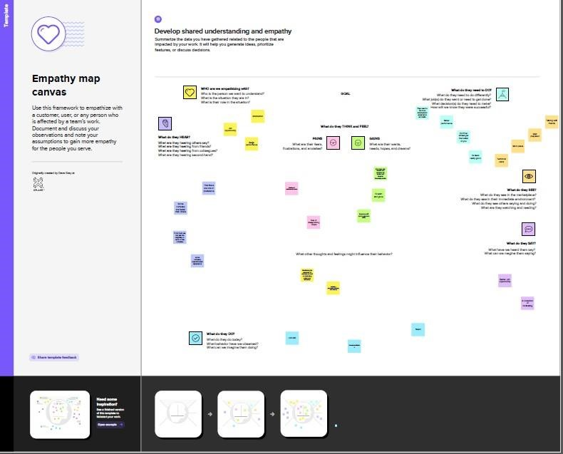

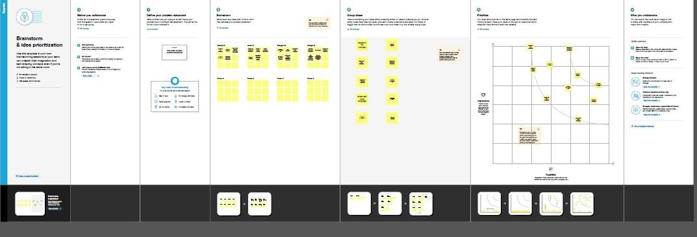

**IDEATION & BRAINSTROMING MAP**

**RESULT**

**Final finding output of the project**

* **Index.html**

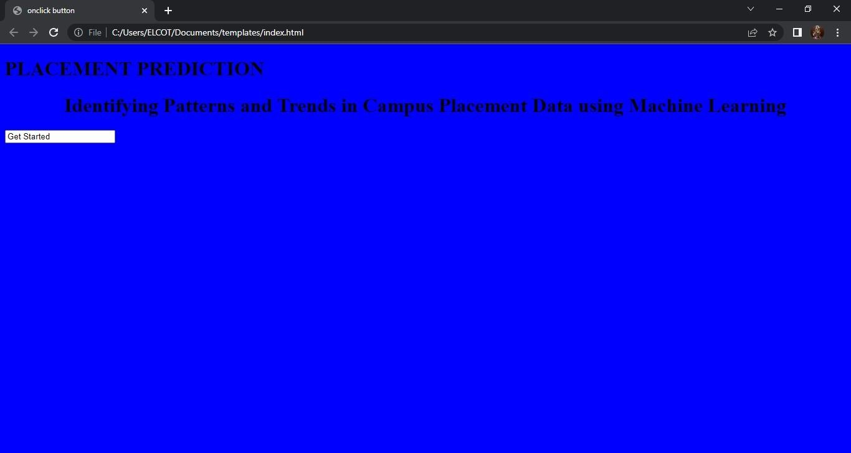

* **Index1.html**



* **Second page.html**

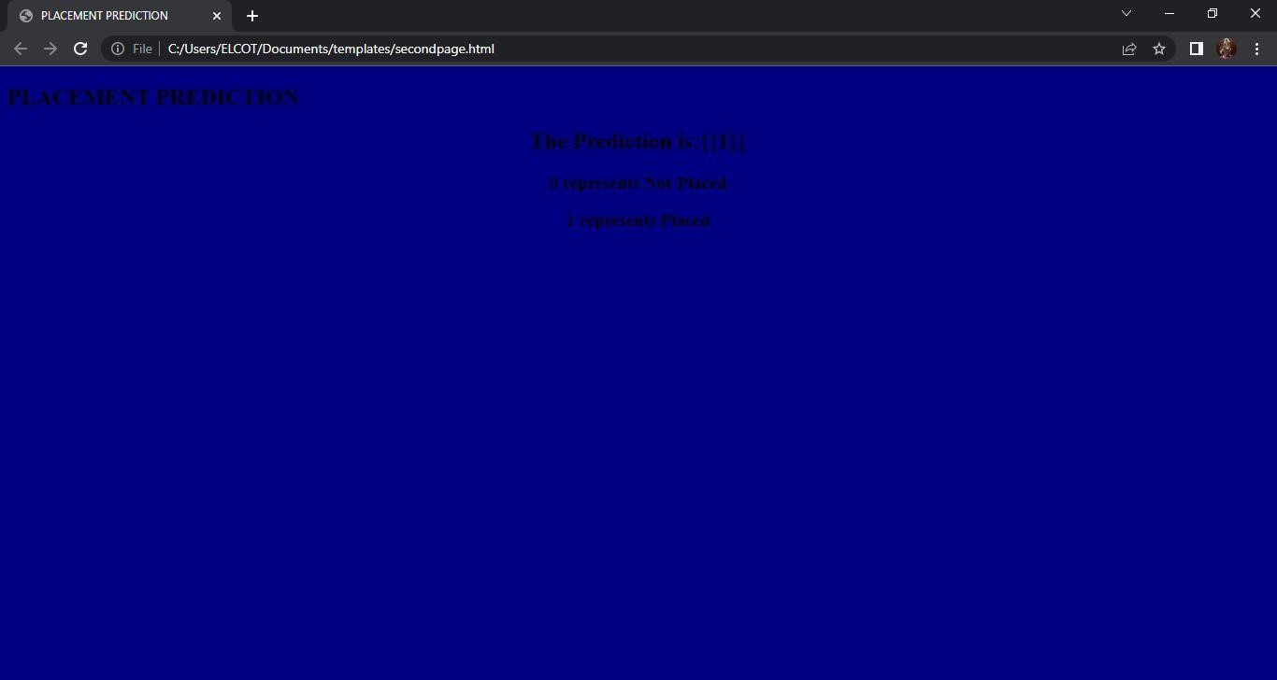

**ADVANTAGE OF CAMPUS PLACEMENT:**

* The companies will be benefited from getting wide choice of candidates to select for different jobs.
* The companies will be benefited from getting wide choice of candidates to select for different job posts.
* Companies can select the right and talented candidate from a vast pool of young applicants within a limited time.
* On the other hand, students have the advantage of getting a good job according to their qualification level even before the completion of their academic course in college.

**DISADVANTAGES OF CAMPUS PLACEMENT**:

* Campus recruitment is an

expensive affair for majority of the companies as it adds up costs to the bottom line.

* Companies incur different expenses related to travel, boarding, training etc while conducting campus selection process.
* The experienced and skilled candidates having practical job exposures cannot be recruited through campus placements.
* Fresh candidates selected through campus placements require adequate training for work.
* This is an additional expense for the company. Also, students can’t work with their dream company and will have to remain satisfied with the company that recruits them during campus selection. **APPLICATION**
* Companies hold on campus

recruitment drives for students in their final year, and sever large. ➢ You can expect questions related to coding, algorithm and machine learning.

# CONCLUSION

* Goal for future placement
* Performance of student

o At the completion of placement, student and supervisors should complete the end of placement evaluation form.

oTo determine what merits satisfactory or unsatisfactory performance on placement.

# FUTURE SCOPE

* Given the boom in the market, college grads or undergrads have access to a wide pool of employers promising attractive roles and benefits.
* We need to use technology and creative communication strategies to stay top of mind in our target demographic.

# APPENDIX

Source code

PLACEMENT_PREDICTION.ipynb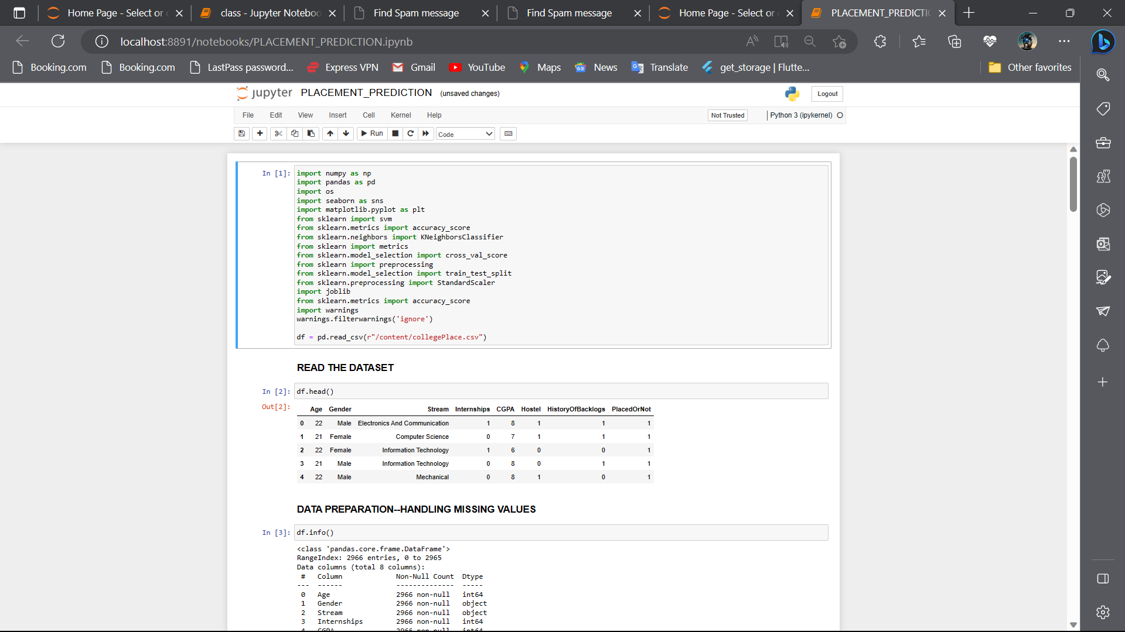

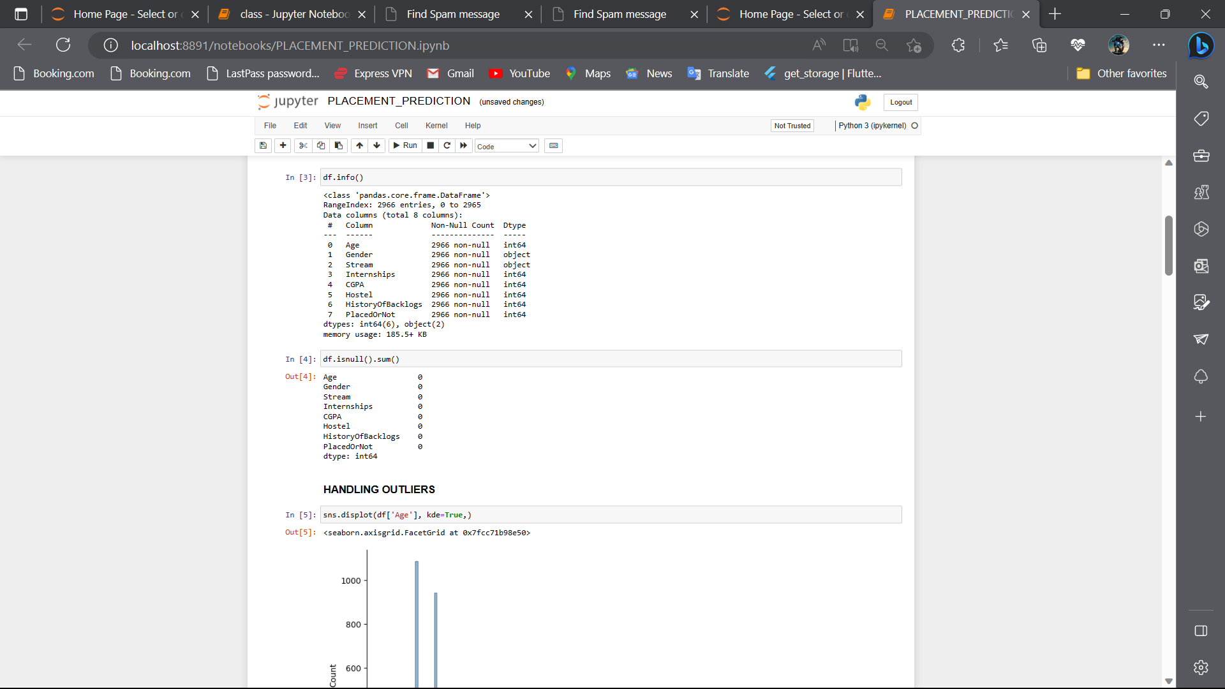

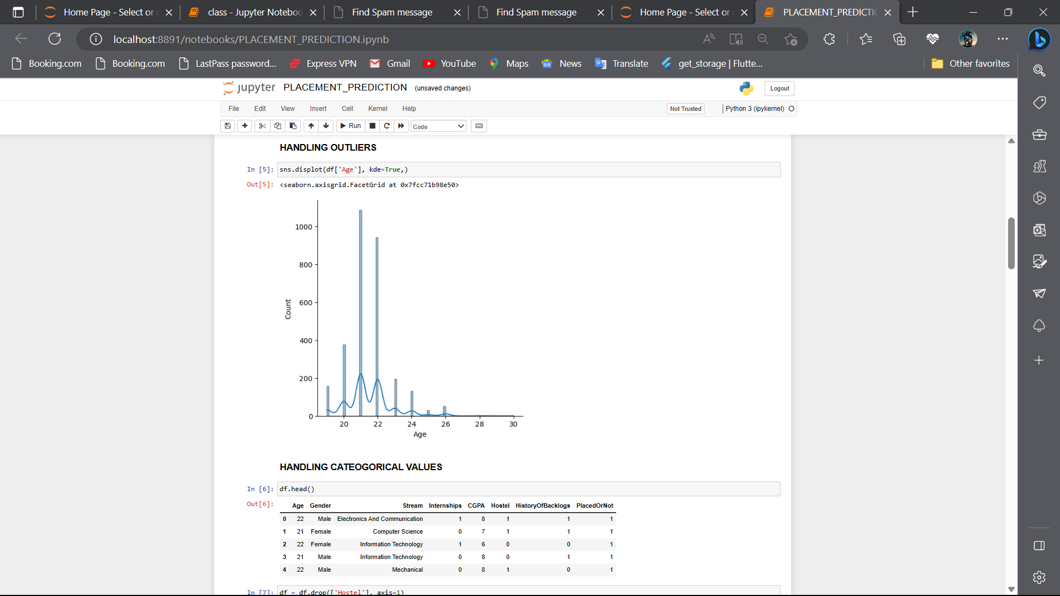

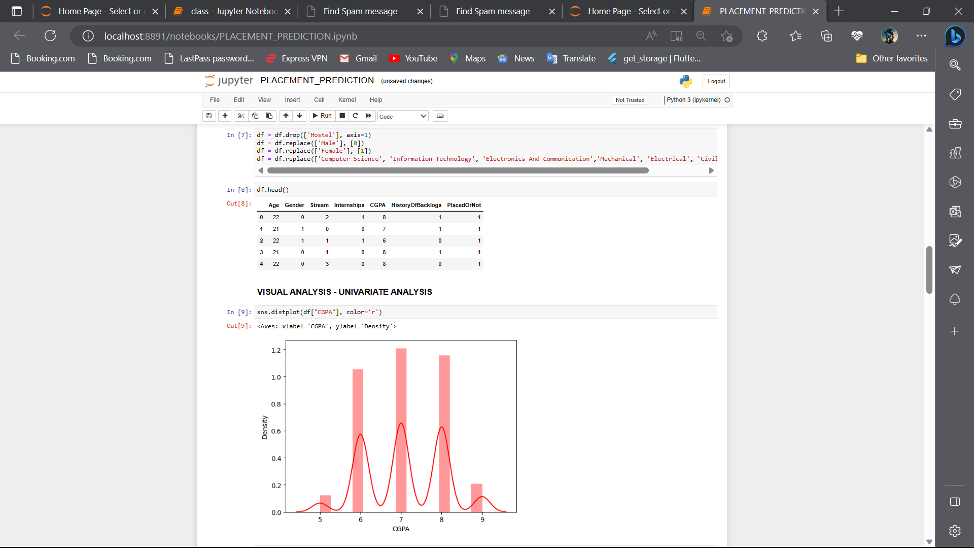

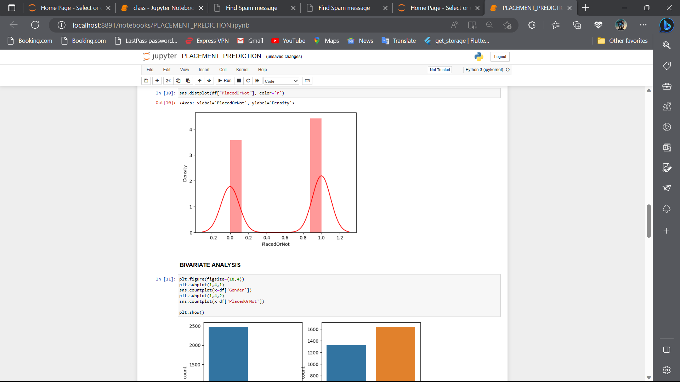

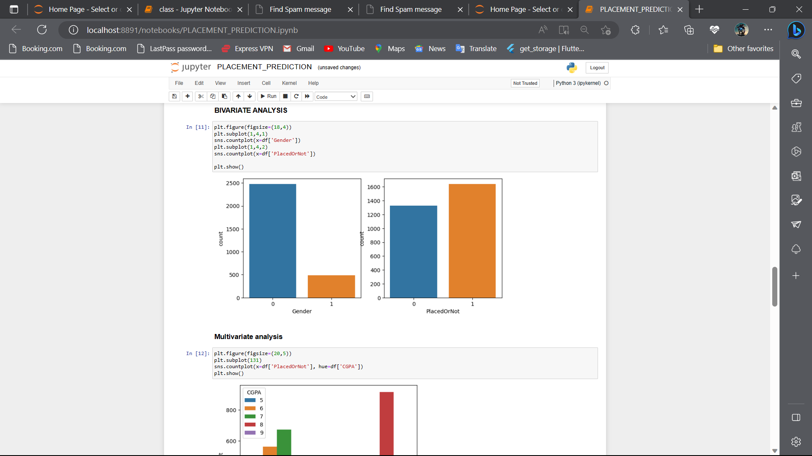

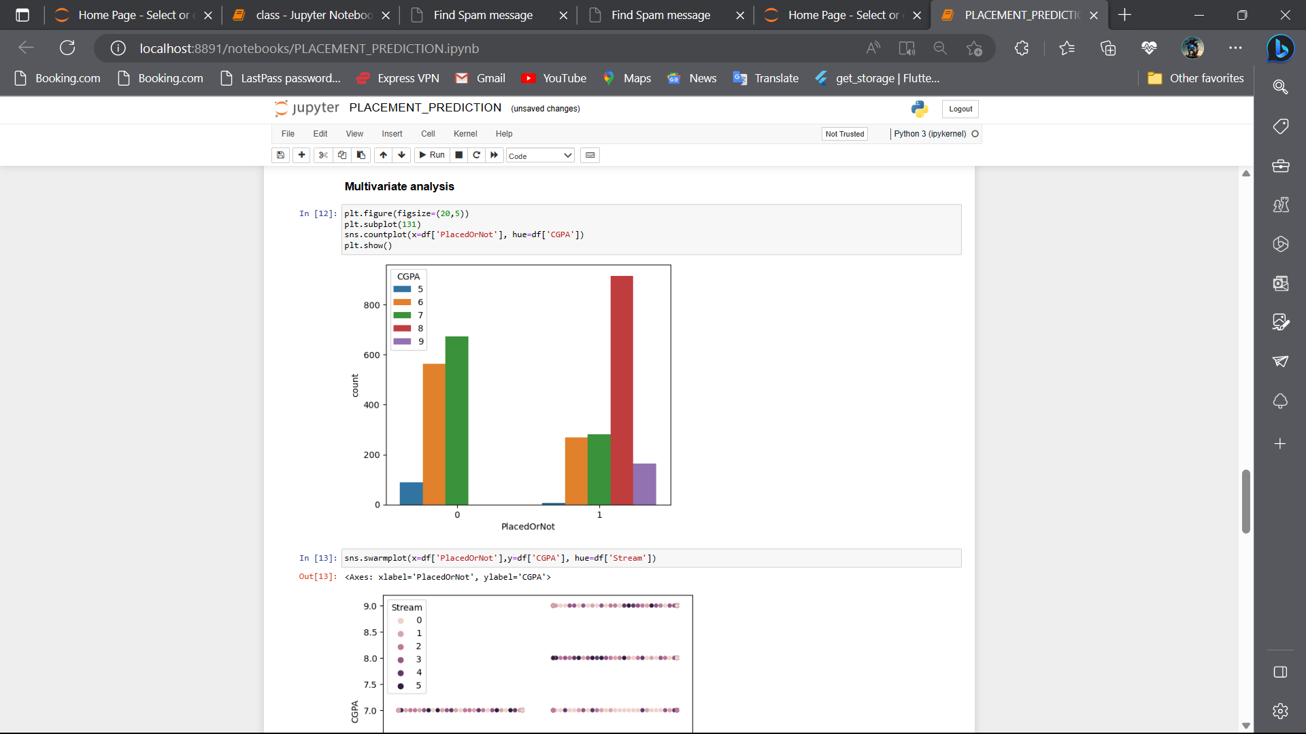

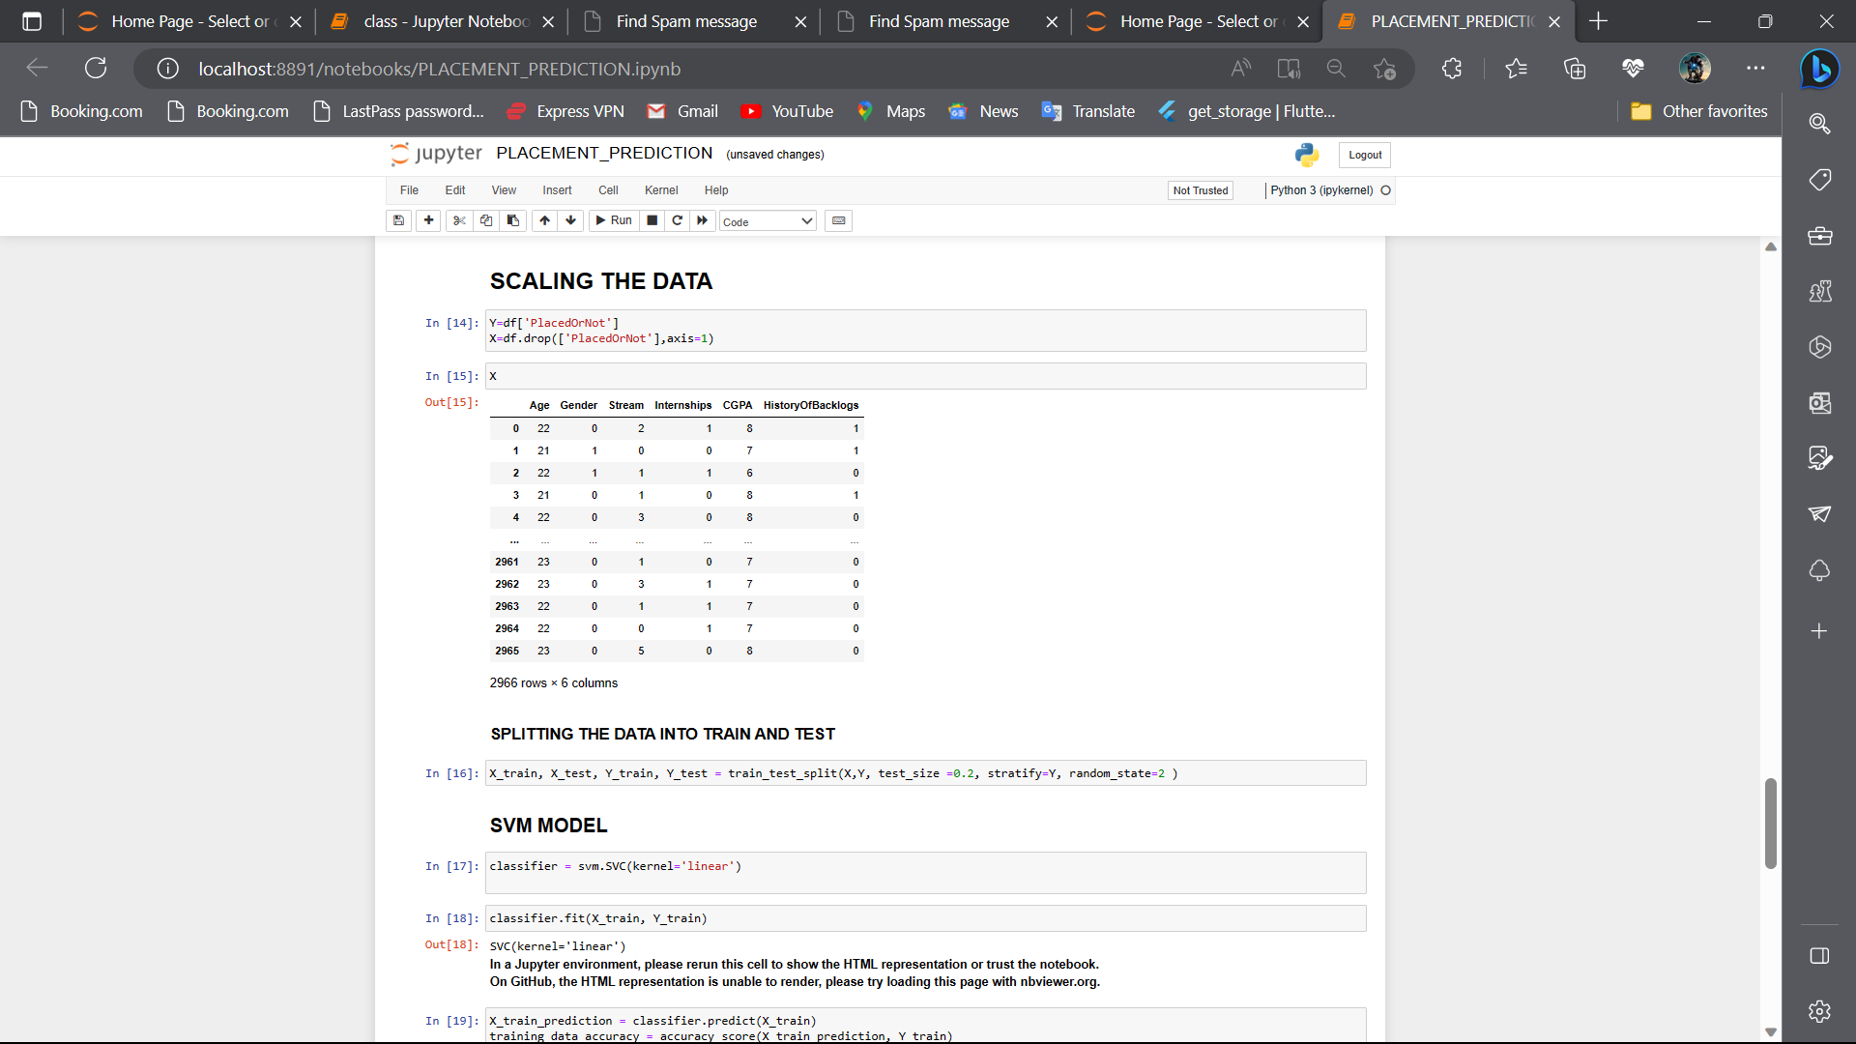

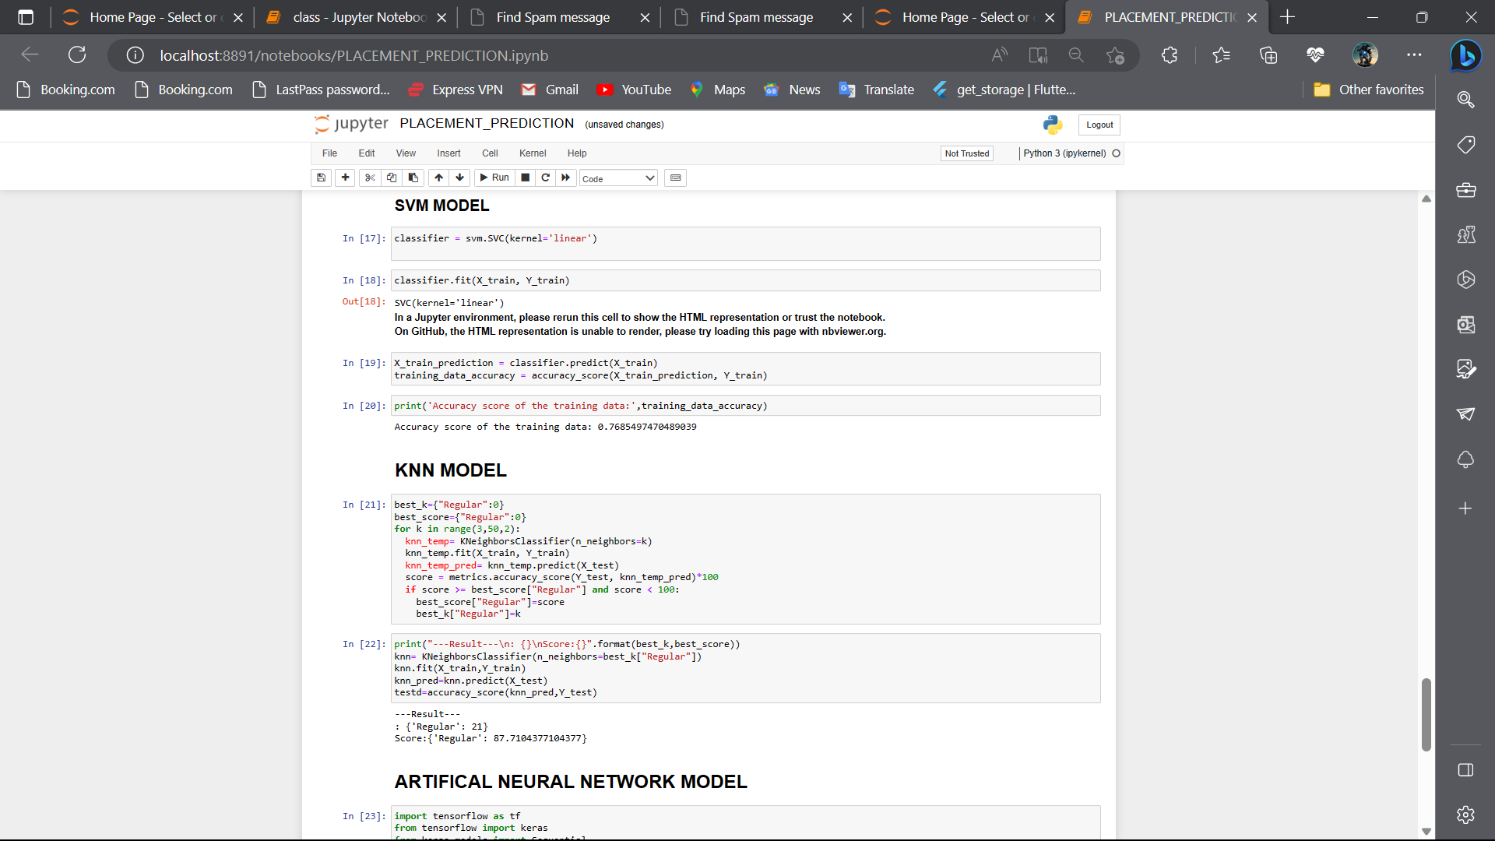

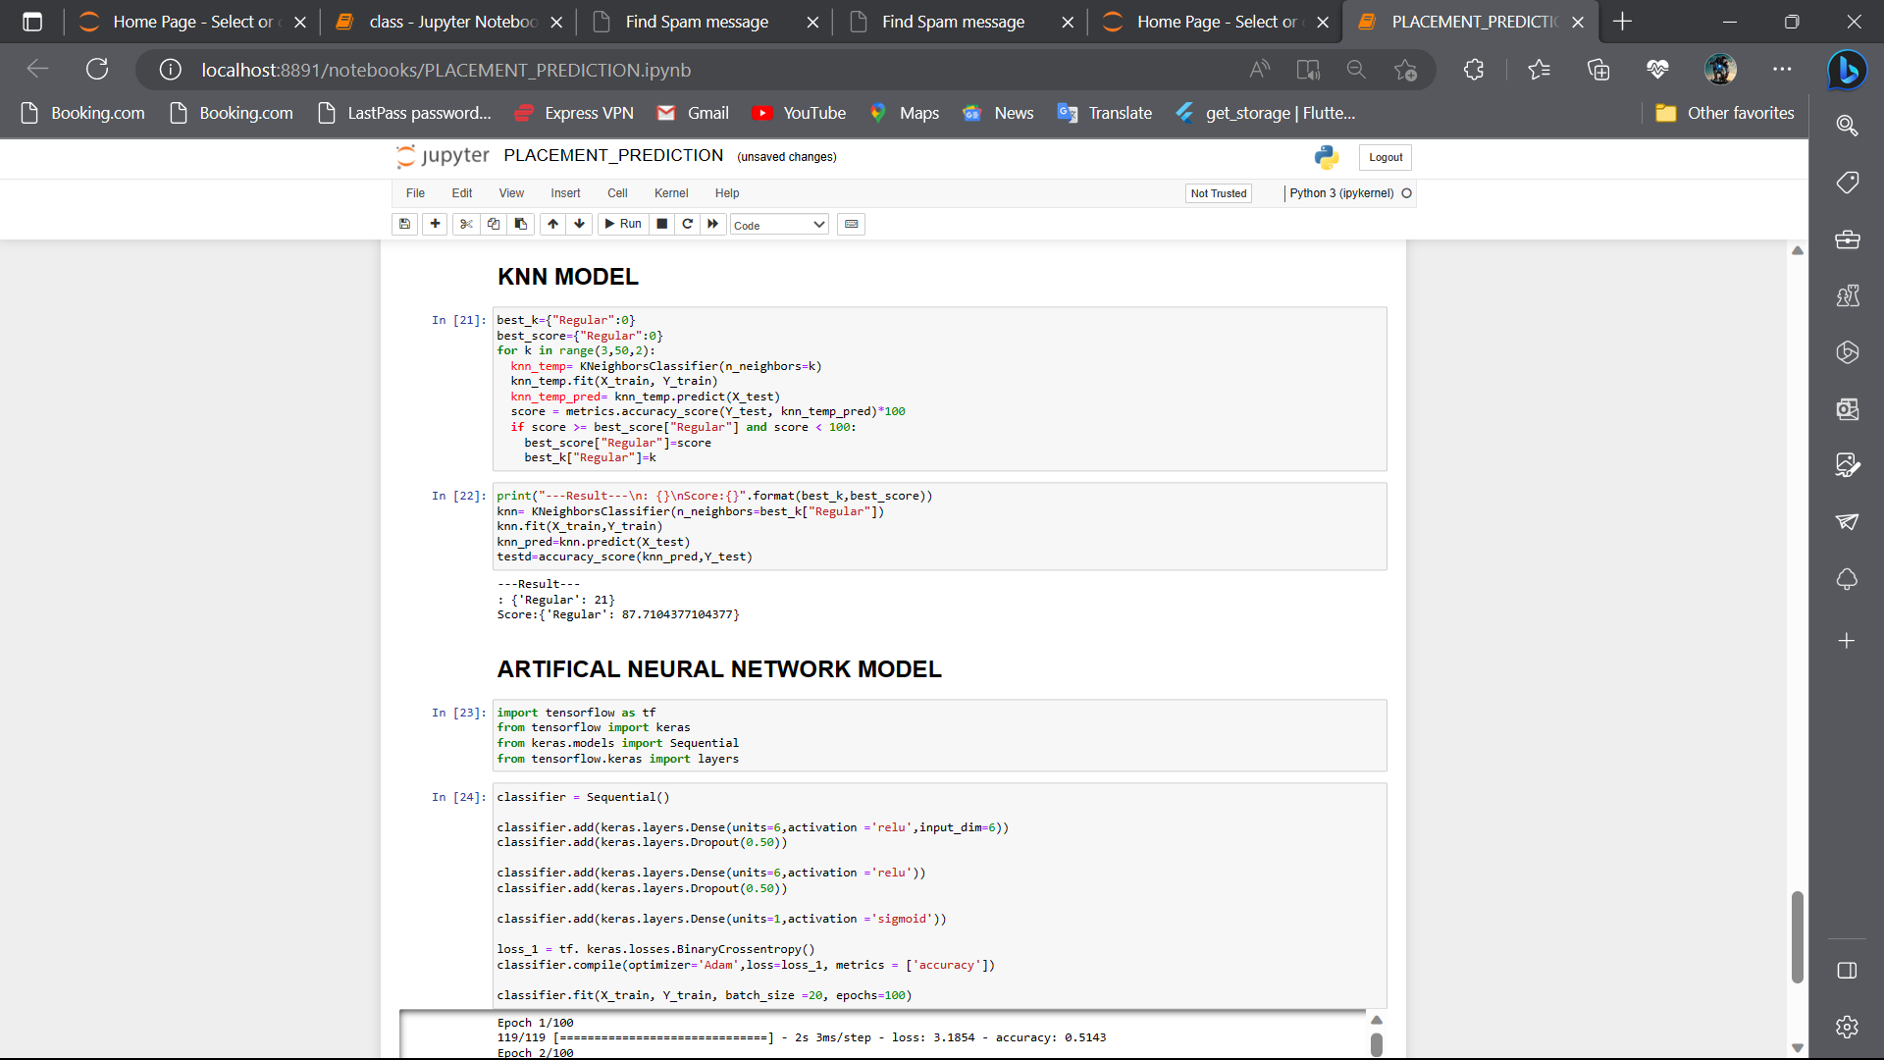

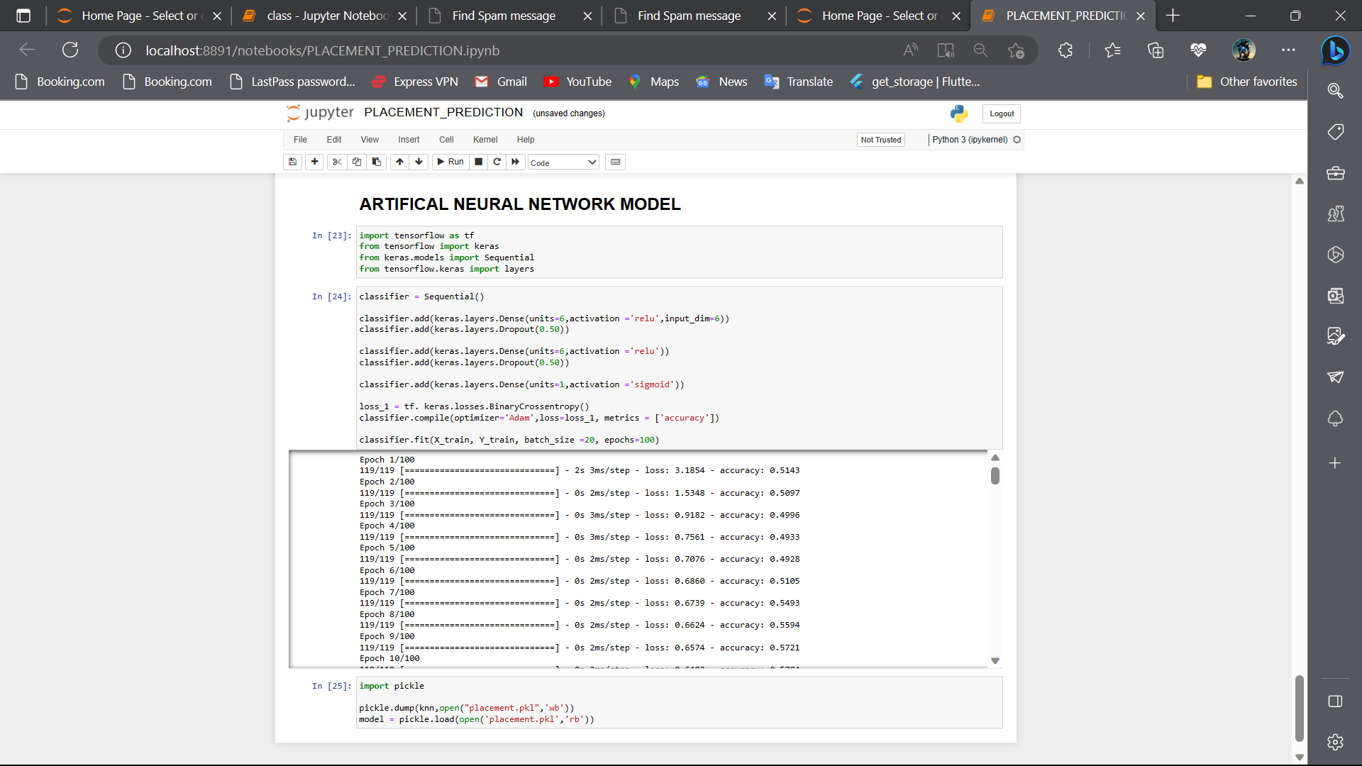

**About.html**

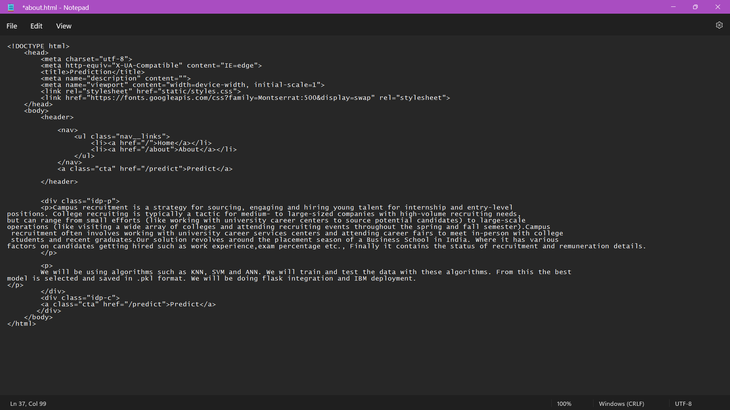

**Home.html**

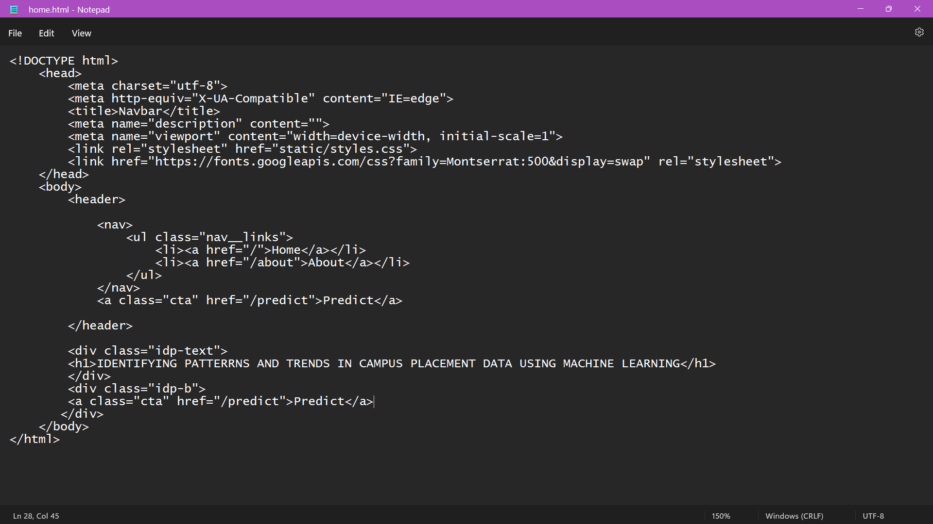

**Predict.html**

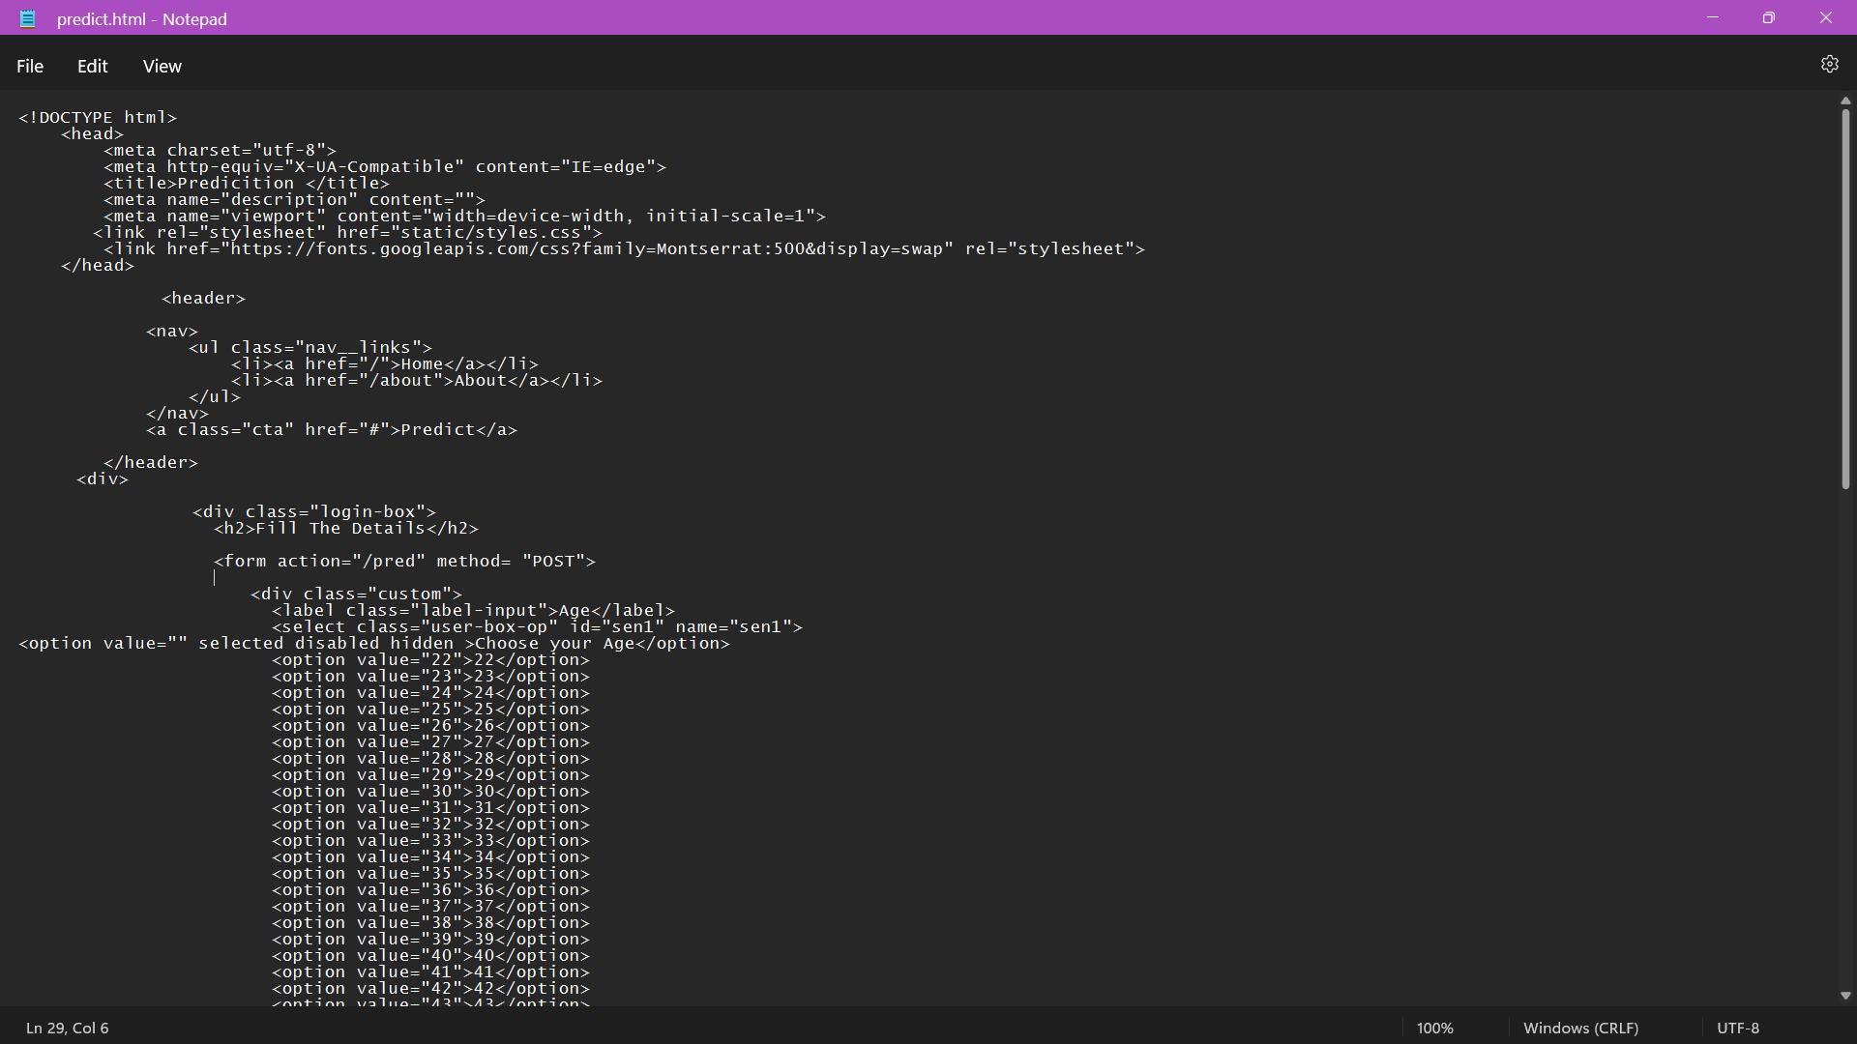

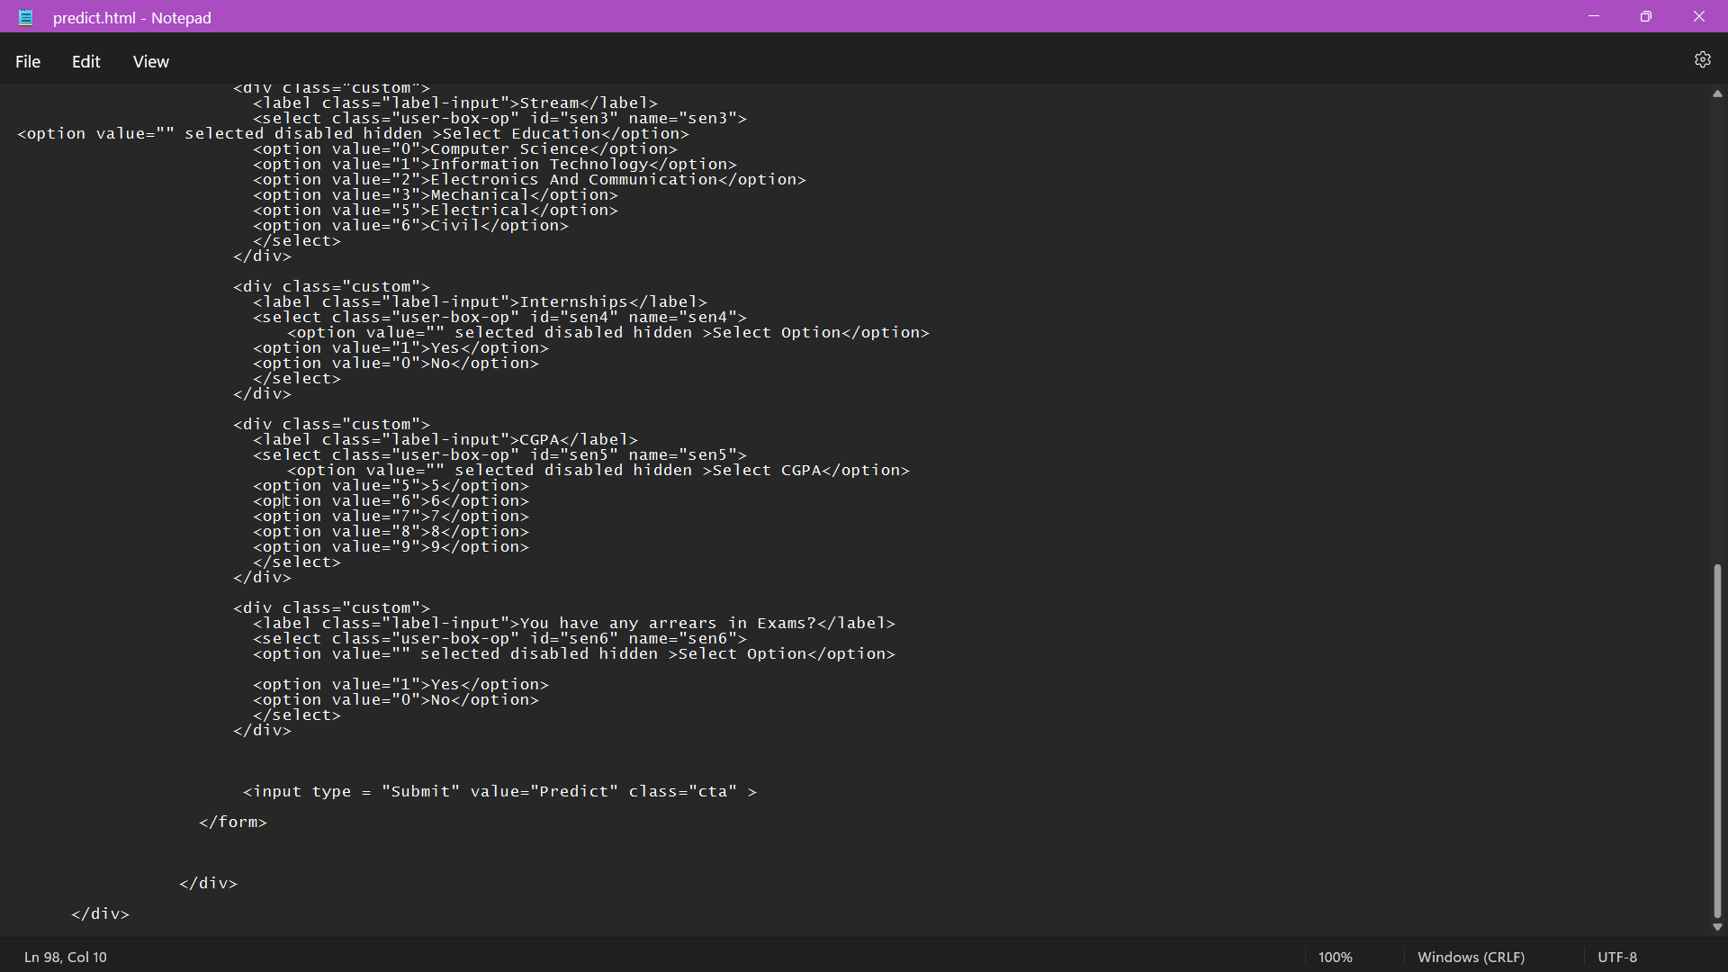

**Submit.html**

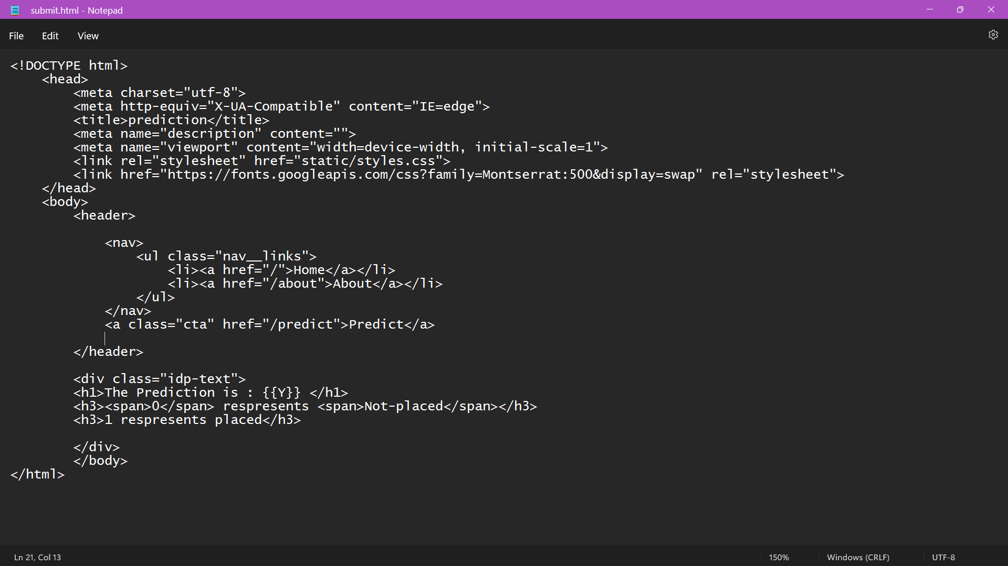

**App.py**

